Now that you have developed new skills and knowledge in cybersecurity, it’s time to start preparing for interviews. [Interview Warmup](https://grow.google/certificates/interview-warmup/)

is a tool that helps you practice answering questions to become more confident and comfortable throughout the interview process.

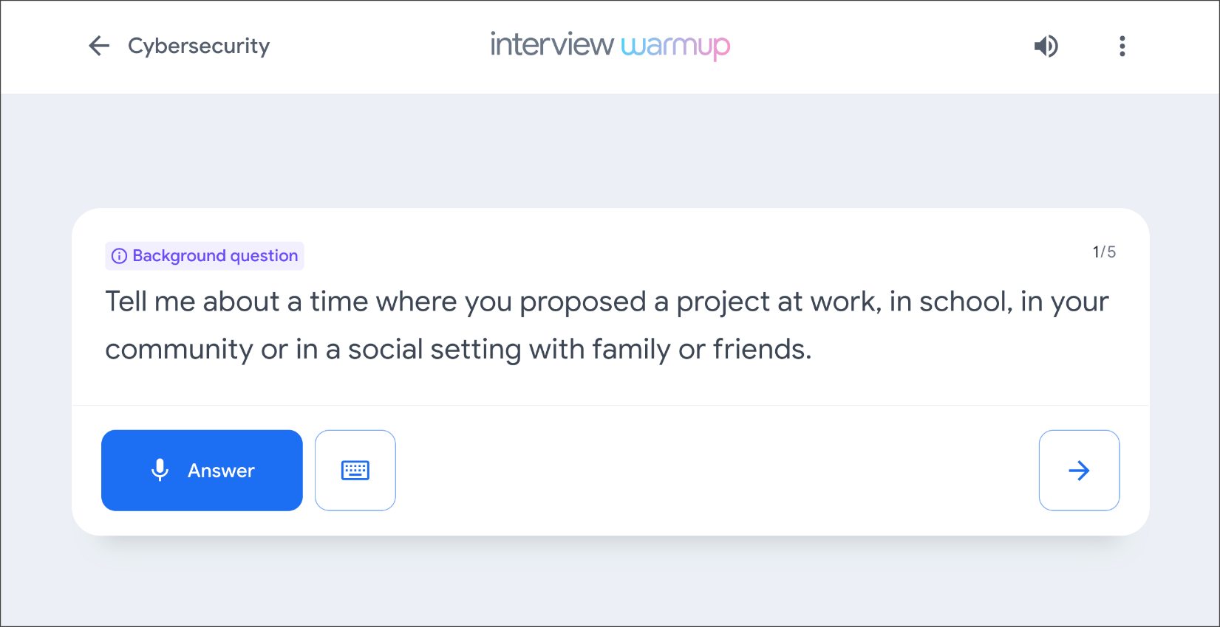

**Get started**

Follow these steps to start a five-question practice interview related to cybersecurity:

1. Go to [grow.google/certificates/interview-warmup/](https://grow.google/certificates/interview-warmup/)
2. Click **Start practicing**.
3. Select **Cybersecurity** to open an additional menu.
4. Click **Start**.

The interview lasts about 10 minutes, and the questions will vary with each attempt. During each interview session, you will be asked two background questions, one behavioral question, and two technical questions. You are encouraged to try as many practice interviews as you want.

You can also review complete lists of [cybersecurity interview questions](https://grow.google/certificates/interview-warmup/category/cybersecurity/)

or [general interview questions](https://grow.google/certificates/interview-warmup/category/general/all-questions/)

if you'd like to focus on a particular topic.

**How it works**

Interview Warmup asks you interview questions to practice answering verbally. Your answers will be transcribed in real time, allowing you to review how you responded. In addition, Interview Warmup's machine learning algorithm can detect insights that can help you learn more about your answers and improve the way you communicate.

Here are a few examples of questions Interview Warmup might ask:

* What are your career goals for the next five years?
* What processes can you use to ensure user data is protected?
* Name two types of common cybersecurity attacks?
* What are two internal factors that can increase the chances of security risks?
* What do security information and event management tools enable security analysts to do?
* In Python, what’s the difference between break and continue?

Here are some of the insights that Interview Warmup provides:

* **Talking points:** The tool lets you know which topics you covered in your answer, such as your experience, skills, and goals. You’ll also be able to view other topics that you might want to consider covering.
* **Most-used words:** The tool highlights the words you used most often and suggests synonyms to broaden your word choices.
* **Job-related terms:** The tool highlights the words you used that are related to the role or industry in which you are preparing to work. You’ll also be able to view an entire list of job-related terms that you might want to consider including in your answer.

Interview Warmup gives you the space to practice and prepare for interviews on your own. Your responses will be visible only to you, and they won’t be graded or judged.

**Key takeaways**

Practicing for interviews is an important skill for your career in cybersecurity. Using Interview Warmup can help you practice interview questions and receive feedback in real time. As you practice, you will gain confidence and be able to prepare more polished responses for common interview questions.